Abstract title (left, 14-point bold, Cambria)

A. PresentingAuthor¹, B. Author¹, C. Author² (left, 10-point, Cambria)
¹Institute of Interesting Results, Anytown, Anyland (left, 10-point, Cambria, Italic)
²Another Institute, Anytown2, Anyland2 (left, 10-point, Cambria, Italic)
E-mail: PresentingAuthor@world.com (left, 10-point, Cambria, Italic)

Abstracts must be written in English and the preferred length of the abstract is about 300 words. We would like to ask you to submit your abstract as a single A4-page Word document by overwriting this template. Overwriting this document instead of starting a new one will preserve all the styles necessary for automated document processing. The name of the presenting author should appear first in the list of authors and underlined. The e-mail address of the presenting author is recommended.
The text should be single-spaced, and each paragraph indented as indicated here. The text should be justified. Use 10-point Cambria typeface, and Symbol font if necessary. Your abstract is limited to one page of the A4 paper. The margins must be 2.0 cm on all sides for A4 paper. If images are included, please make sure that the resolution is suitably high (300 dpi or higher). Please do not put in the abstract more than one figure (see Figure 1). For best results, submit artworks in the actual size and do not resize them in the word processor. References in the text must be enclosed in square brackets [1].

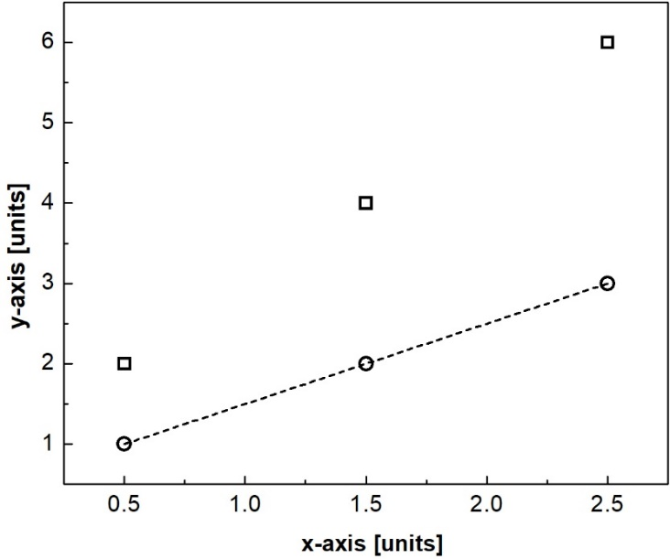
Figure 1. Figure name (center, 10-point, Cambria)

Abstracts must be submitted in English, and all presentations must be made in English. Abstracts are subject to review [1,2].
Abstracts will be published exactly as submitted. Copy should be checked for accuracy and typographical problems before submission. Please do not convert your abstract into a PDF file.
The abstracts should be uploaded in the ABSTRACTS section of the conference site.
Funding acknowledgment (if applicable).
References:
[1] A. Author, B. Author, C. Author and D. Author, Journal Title 22 (2022) 1922.
[2] A. Author and B. Author, Book Title, pp. 1–100, Publisher (2022).

